Calculus Culminating Activity
Part 1 – Optimization Problems – 16 marks
Before you start answering the questions in part 1 you should look at the new lessons on Optimization found in the Culminating Activity content section. This will show you how to correctly set up and answer these questions.
Select only two of the following three questions. For each question, include a labelled diagram, state restrictions and provide a complete written solution with closing statements.
- A rectangular piece of cardboard, 120 cm by 50 cm, is going to be used to make a rectangular box with an open top by cutting congruent squares from the corners. Calculate the dimensions (to one decimal place) for a box with the largest volume.

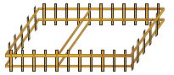
- Two pens with one common side are to be built with 60 m of fencing. One pen is to be square, the other rectangular, as shown. Find the dimensions that maximize the total area.

- A cylindrical chemical storage tank with a capacity of 1000 m³ is going to be constructed in a warehouse that is 12 m by 15 m, with a height of 13 m. The specifications call for the base to be made of sheet steel that costs $90 m², the top to be made of sheet steel that costs $50 m², and the wall to be made of sheet steel that costs $60 m².
Determine the proportions that meet the conditions and that minimize the cost of the steel for construction.

NOTE: The height was 11m in old version.

Part 2 – Sinusoidal Word Problem – 8 marks
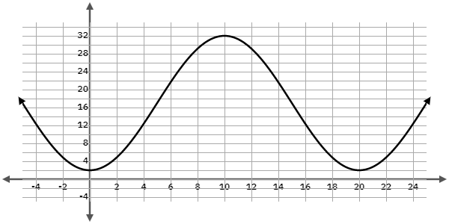
The graph shows a rider’s height, in metres, on a Ferris wheel in terms of time, in minutes.
a) What are the maximum and minimum heights for the rider?
b) Write an equation for the rider’s height, h(t), in terms of time.
c) Write an equation for $h^{'}(t)$.
d) At what rate is the rider’s height changing when t = 4? t = 28?
e) Is the rider’s height increasing or decreasing when t = 15? How quickly is it changing?
f) What is the maximum rate at which the rider’s height is changing?

Part 3 – Exponential Word Problem – 10 marks
In this question you are encouraged to use DESMOS to verify the accuracy of your two equation in Part a) and c) . Include two separate screen shots from DESMOS that shows your equations from a) and c) passing through the points points.
